Welcome to First Grade!!
My name is Mrs. Menghini and I am so excited to have the opportunity to work with you and your child, this upcoming school year! It's going to be a year full of fun, learning and lots of new adventures.
I am married to my husband, Joe. We have two children, our son, Jack is 5 and our daughter, Zora, is 2. Together, as a family we love to spend our time outdoors. Hiking, biking, camping and traveling.
I moved to Traverse City, 9 years ago, from Sault Ste. Marie Ontario. Yes, I am Canadian!!! Growing up in Canada, I spent my years playing hockey and dancing.
Communication is very important, so please feel free to contact me at anytime at ​smenghini@buckleyschools.com​. I’m looking forward to a wonderful school year, together!
All of our Buckley Bears are expected to use behavior that is safe, respectful and responsible. We use the letters in PRIDE to remind us that we choose to demonstrate... Personal responsibility
Respect
Investment in our learning
Determination
Effort​.

Please join us for our ​Open House​!!
August 29, 2019 from 5-7pm ​at Buckley Community Schools. Enjoy the rest of your summer and see you at the open house! GO BEARS!

Mrs. Menghini

Supplies
Please see our first grade supplies list on the next page. Daily required supplies include:
- Backpacks
- Healthy Snacks
- Extra set of clothes (these can be kept in your child’s locker)

First Grade Supplies List
If possible, please bring supplies to open house on August 29th.
This way we have time to organize and put things away prior to the first day
of school.
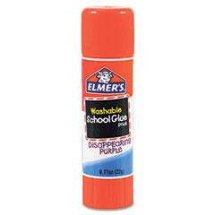  Glue Stick | 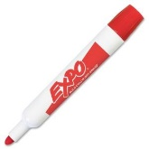  2 Black Expo Dry Erase Markers | 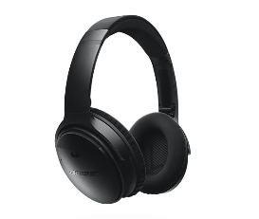  1 Pair of Headphones | 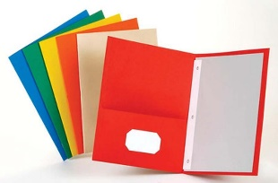  1 Study Folder
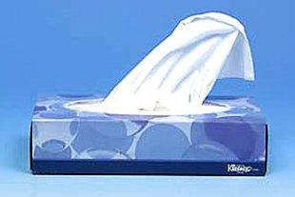  Kleenex | 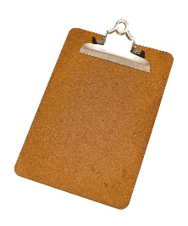  1 Clipboard | 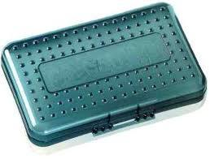  1 Plastic Pencil School Box | 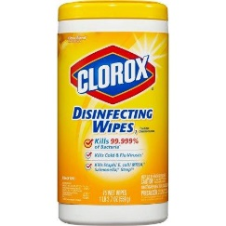  Clorox Wipes
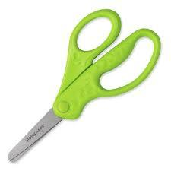  1 Pair of Kid Scissors | Sandwich Ziploc Bags | 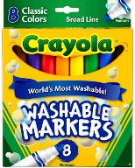  Markers | 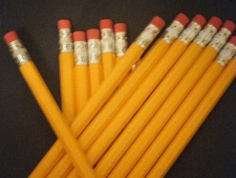  Box of Pencils

Wish List Items

Colored Printer Paper  (any colors) | Construction Paper

